**ROLL NUMBER: 202312461**

**GITHUB: juniorcholong@gmail.com**

**App Review**

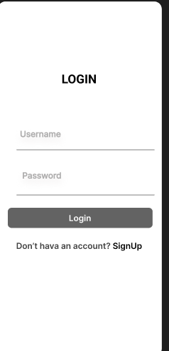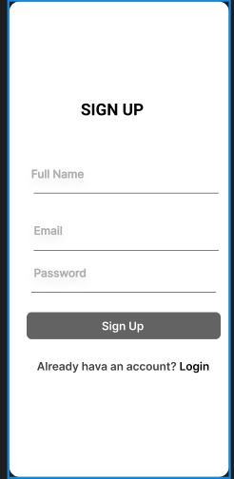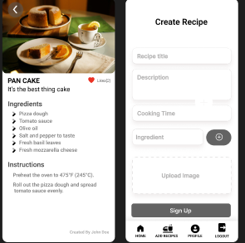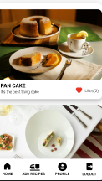

**Culinary Connect: Your Digital Recipe Hub**

**Application Overview:**

**Culinary Connect is a dynamic mobile application designed to foster a vibrant community around the joy of cooking and sharing recipes. Developed using the versatile Flutter framework for cross-platform compatibility and powered by Google's robust Firebase suite, the app offers an intuitive platform for culinary exploration and content creation.**

**Key Features:**

1. **User Onboarding (Sign-In & Registration):**
   * **Seamless Access: Users can effortlessly create new accounts or sign in to existing ones using their email credentials.**
   * **Personalized Experience: Secure authentication enables users to access and manage their unique culinary profile, including recipes they've contributed and those they've favorited.**
   * **Visually Engaging Interface: The sign-in and registration pages, inspired by the provided design (Screenshot 2025-07-13 225033.png), feature a clean, dual-panel layout, ensuring a user-friendly and aesthetically pleasing start to their app journey.**
2. **Recipe Discovery (Home Feed):**
   * **Explore a World of Flavors: Users can browse an extensive and ever-growing collection of recipes submitted by fellow food enthusiasts.**
   * **Efficient Search: A prominent search bar allows for quick and precise discovery of desired recipes.**
   * **Engaging Previews: Each recipe is showcased in a visually appealing card format (as seen on the left side of Screenshot 2025-07-13 225758.jpg), providing a glimpse of the title, a concise summary, estimated preparation time, and popularity metric, accompanied by an enticing image.**
   * **Community Interaction: Users can express their appreciation for recipes through an intuitive liking mechanism, contributing to the app's interactive ecosystem.**
3. **Recipe Creation (Contribution Hub):**
   * **Share Your Culinary Genius: The app empowers users to easily publish their own original recipes for others to enjoy.**
   * **Structured Recipe Input: The dedicated creation interface (depicted on the right side of Screenshot 2025-07-13 225758.jpg) facilitates the entry of essential recipe details such as title, detailed instructions, preparation duration, and the flexible addition of multiple ingredients.**
   * **Visual Enhancement: Users can upload high-quality images to accompany their recipes, making them more attractive and informative.**
4. **In-Depth Recipe View (Detail Page):**
   * **Complete Recipe Immersion: A dedicated screen provides a comprehensive breakdown of any selected recipe, featuring its full title, detailed preparation steps, an exhaustive list of ingredients, cooking duration, author attribution, and the total number of endorsements.**
   * **Rich Visuals: The recipe's accompanying image is prominently displayed, offering an immersive visual complement to the textual information.**
5. **Personalized Profile (My Kitchen):**
   * **User-Centric Dashboard: Users can access their personal profile, showcasing their basic account information, including their name and email address.**
   * **My Contributions: This section serves as a personal archive, displaying all recipes the user has contributed, offering a convenient overview of their culinary footprint within the app.**

**Backend Architecture (Firebase Firestore):**

**The application leverages a streamlined and robust data model within Firebase Firestore:**

* **users Collection: Stores individual user credentials and profiles.**
  + **userId: The unique identifier for each user's document.**
  + **name: The user's registered name.**
  + **email: The user's primary email address.**
  + **createdAt: Timestamp indicating when the user's account was created.**
* **recipes Collection: Houses all culinary creations.**
  + **recipeId: The distinct identifier for each recipe document.**
  + **title: The name given to the recipe.**
  + **description: A detailed narrative outlining the recipe.**
  + **ingredients: An ordered list of components required for the recipe.**
  + **cookingTime: The estimated duration for preparing and cooking the dish.**
  + **imageUrl: The web address of the recipe's associated image, hosted on Firebase Storage.**
  + **authorId: The user ID of the individual who submitted the recipe.**
  + **authorName: The display name of the recipe's creator.**
  + **likes: A numerical count representing the recipe's endorsements.**
  + **likedBy: A collection of user IDs that have marked the recipe as a favorite.**
  + **createdAt: Timestamp reflecting the date and time the recipe was added.**

**Technology Stack:**

* **Front-End Development: Flutter (Dart language)**
* **Back-End Services: Firebase (Firestore for database management, Authentication for user identity, Cloud Storage for media assets)**
* **State Management Solution: Provider**